_{Deliverable} #1 (1 Marks) due week 5 for professor review and feedback. -Rohaan
Based on the list of requirements you gathered in Part A of the project, develop a set of goal use cases per use case identify the actors (Operational stakeholders) involved and the requirements they relate to. Name each use case to reflect the functionality it serves using the name convention “Verb-Noun ” group the uses cases under two or three sub-systems / modules. You can base your grouping based on the similar functional areas or based on types of operational stakeholders, who are your end users. Add the use case table to section # 3 of your SRS document.

Use cases
Use Case name | List of related Requirements ID | Actor (s) | Brief Description
Create Account | FR002, FR003, FR010, FR014 | Artist, Songwriter, Singer, Buyers, Sellers | The actor (All) will be prompted by the app to fill in each empty field including: Email, username, birth name, birthdate, phone number, and country of residence; after filling in all the fields, the actor will press “Next” and be prompted to enter their banking information, the user will click “Submit Banking Info” after filling in all fields and proceed to make a password, and after entering their password, they click “Create Account”. The user will then see their homepage. The user would have to upload their profile picture and the profile description. The actor will receive an email notification stating their account and bank accounts are connected/created successfully.
Complete Tutorial | FR009 | Artist, Songwriter, Singer, Buyers, Sellers | After registration, the actor (All) will be guided by the bot and be introduced to the main functionalities that the app has to offer.
Upload Lyrics | FR006, FR022, FR030, FR032, FR033 | Song Writers, Artists, Sellers | The actor (Sellers) will open a new UI and fill in the following fields: Lyric Title, language, song file (txt, word, etc.), full name, Phone Number, Email, and Cost of the lyric and any other users involved in the lyric; the user will then be asked to enter their password and after entering their password, press submit lyric. The actor will see a message saying the lyrics have been uploaded.
Search Lyrics | FR007, FR022, FR023, FR024 | Artist, Songwriter, Singer, Buyers, Sellers | The actor (All) will type a song name, artist, or keywords and select the available search tags, and finally press enter. The actor will then see up to 5 lyric listings that relate to their input search and filters on their screen and will scroll up to view more lyric listings.
Stream Music | FR050 - FR065 | Artists, Songwriter, Singer, Buyers, Sellers, Song Listeners, Spotify Users | The actor (All) will press the Spotify logo in the top left of their screen, the actor then will see a similar UI to the Spotify app. The actor will click their desired song, playlist, album, or artist and click the play button to listen to their selected music.
Connect Accounts | FR049 | Artists, Songwriter, Singer, Buyers, Sellers, Song Listeners | The actor (All) will press on one of the link account buttons (Spotify, Instagram, Facebook, etc.) the actor will then get a new badge that they have linked to their other social media account.
Obtain Badges | FR001, FR047, FR048, FR049 | Artists, Songwriter, Singer, Buyers, Sellers, Song Listeners | The actor (All) will complete an activity within the app and will receive an in-app notification stating they have obtained a badge; the actor will then click the in-app notification and see the badge on their profile page alongside all obtained badges and other available badges.
Report Actors | FR005, FR008, FR014, FR037 | Artists, Songwriter, Singer, Buyers, Sellers, Song Listeners | The actor (All) will open the report tab on the other actor’s profile page, the actor will select the reason for reporting the other actor and then the report will be sent to the UX Team.
Edit Profile | FR010, FR028, FR042, FR048 | Artists, Songwriter, Singer, Buyers, Sellers, Song Listeners | The actor (All) will open their profile and select ‘edit profile’ the actor will then change their profile picture, username, profile description, displayed badges,
Add Friends | FR012, FR015, FR017, FR038 | Artists, Songwriter, Singer, Buyers, Sellers, Song Listeners | The actor (All) will open the other actor's profile and press the add friend button and the actor will then see the other actor in their feed more often and can message the other actor as well.
Review Actors | FR011, FR018, FR019, FR020 | Artists, Songwriter, Singer, Buyers, Sellers, Song Listeners | The actor (All) will select a profile and press the ‘leave a review’ button on the profile and the actor will fill in a text box and select between 1 and 5 stars to rate the other actor and press ‘submit review’. The actor will be able to view the reviews of the other actors (including their own).
View Reviews | FR011, FR012 | Artists, Songwriters, Singers, Buyers, Sellers | The actor (All) will open their profile by pressing the person icon in the bottom right corner of the screen and then the actor will press the ‘review’ tab and be able to view all reviews made towards or against them.
Share Lyrics | FR001, FR017, FR029, FR040 | Artists, Songwriters, Singers, Buyers | The actor (All) will press the curved arrow icon and see a list of followed/favorited actors to send a hyperlink of the lyric listing; or the actor may choose to send a hyperlink externally to their desired social media application to any individual user on the other app. The other actor receiving the message will see the notification for the lyric shared.
Like Content | FR020 | Artists, Songwriters, Singers, Buyers | The actor (All) will see a ‘thumbs up’ icon near the top of the lyric listing (or comment), the actor may click the thumbs up icon, the app will add 1 like to the like count.
Comment on Lyrics | FR001, FR018, FR019 | Artists, Songwriters, Singers, Buyers, Sellers | The actor (All) can write and post comments on a lyric listing, the actor will type into a textbox, and when ready press ‘post’. The actor will also be able to view any and all other comments from other actors, the actor can reply to other comments as well.
Notify Actor | FR001 | Artists, Songwriter, Singer, Buyers, Sellers, Song Listeners | The actor (All) will receive a notification on their device stating a message pertaining to the app. The actor may click the notification to be taken to the related content.
Chat with Actors | FR013 | Artists, Songwriter, Singer, Buyers, Sellers, Song Listeners | The actor (All) will open the chat bubble icon in the bottom left corner and select which actor they wish to communicate with. After clicking an actor, the actor will send a message to the other actor. The actor will also be able to see all previous messages from both actors involved.
Block Actors | FR015, FR016 | Artists, Songwriter, Singer, Buyers, Sellers, Song Listeners | The actor (All) will open another actor’s profile, select in the top right corner the red block user icon the actor will confirm if they wish to block the other actor, and the other actor will be labeled as blocked below their profile username.
Modify Banking-Info | FR025, FR026, FR027 | Artists, Songwriter, Singer, Buyers, Sellers | The actor (All) will open their account settings and press either update, remove, or add banking info. When clicking add or update, the actor will enter their new banking info, and press submit.
Buy Lyrics | FR032, FR035, FR041, FR043, FR045, FR004 | Artists, Singers, Producers, Buyers | The actor (Buyers) will select a lyric listing and view the details of the listing. The actor will then press ‘Buy Lyric’, the actor will enter their banking info (if not provided previously) the actor will then read and sign the legal document then they will enter their password and press ‘submit order’ the actor will then get the new lyric in their lyric library.
Interact with Library | FR035, FR036, FR039 | Artists, Songwriter, Singer, Buyers, Sellers, Producers | The actor (All) will see all uploaded, purchased lyrics in the lyric library page. The actor will add a folder by pressing the plus folder icon. The actor will also be able to view and download lyrics by selecting a lyric and selecting the download icon.
Use Premium | FR046, FR044 | Artists, Songwriter, Singer, Buyers, Sellers, Producers | The actor (All) can choose to upgrade to the “Premium Lyricist”; when upgrading, the actor will have no ads displayed in the app, the ability to upload 5 lyrics, and more.

Deliverable #2 (2 mark) due week 6 for professor review and feedback-Hoang Giang
Select one use case with high priority and develop a textual detailed formal use case description, using the use case template in part 2 "Modeling" under section 8.2.3 page 136. Supplement the use case with a swim lane activity diagram as described in Section 8.5.3 Page 153, explaining the flow of activities between the system and the actor(s). Add the use-case formal descriptions and the activity swim lane diagrams to section #4 of your SRS document.
Use case name: | Searching Lyrics
Iteration | 1, last modification: February 27 by H. Giang Dang
Primary Actor | Buyer
Goal in context | The buyer searches for their desired lyrics and finds what the buyer is looking for.
Preconditions | The Buyer is registered and logged into the Lyricist app.  The app has the newest deployed version of the app.
Trigger | The buyer decides to search for lyrics to purchase.
Scenario: | - The buyer opens the “Lyricist” app.  - The app displays the home page and primary menu at the bottom of the screen.  - The buyer selects the magnifying glass icon.  - The buyer selects the “Search here” bar.  - The buyer’s digital keyboard slides up.  - The buyer types in their desired search.  - The app shows numerous lyric listings.  - The buyer scrolls through the lyric listings.  - The buyer selects their desired lyric listing.  - The app displays the details of the lyric listing.
Exceptions | 1.No search results found: If the buyer's desired search yields no results, the app should handle and display an appropriate message or offer alternative suggestions.  2.Technical issues: In case of technical difficulties such as server downtime or network issues, the app should provide error messages and guidance for the buyer.  3. Incorrect search results: If the search algorithm returns inaccurate or irrelevant results, the app should allow the buyer to refine their search criteria or provide feedback for improvement.
Priority | Moderate priority, to be implemented after basic functions
When Available | Third increment
Frequency of use | Infrequent
Channel to actor | Via app or browser and Internet connection
Secondary actors | System administrator, app
Channels to secondary actors | System administrator: PC- based system  Device: Phone(app), pc(web)
Open Issues | - How will the app collect and process user feedback on search results? Are there mechanisms in place for users to report inaccuracies or suggest improvements?  - How can the search algorithm be optimized to ensure accurate and relevant results? Are there plans for continuous improvement based on user interactions with the search feature?  - What specific improvements can be made to the user interface to enhance the search experience? Are there any usability issues reported by users that need to be addressed?

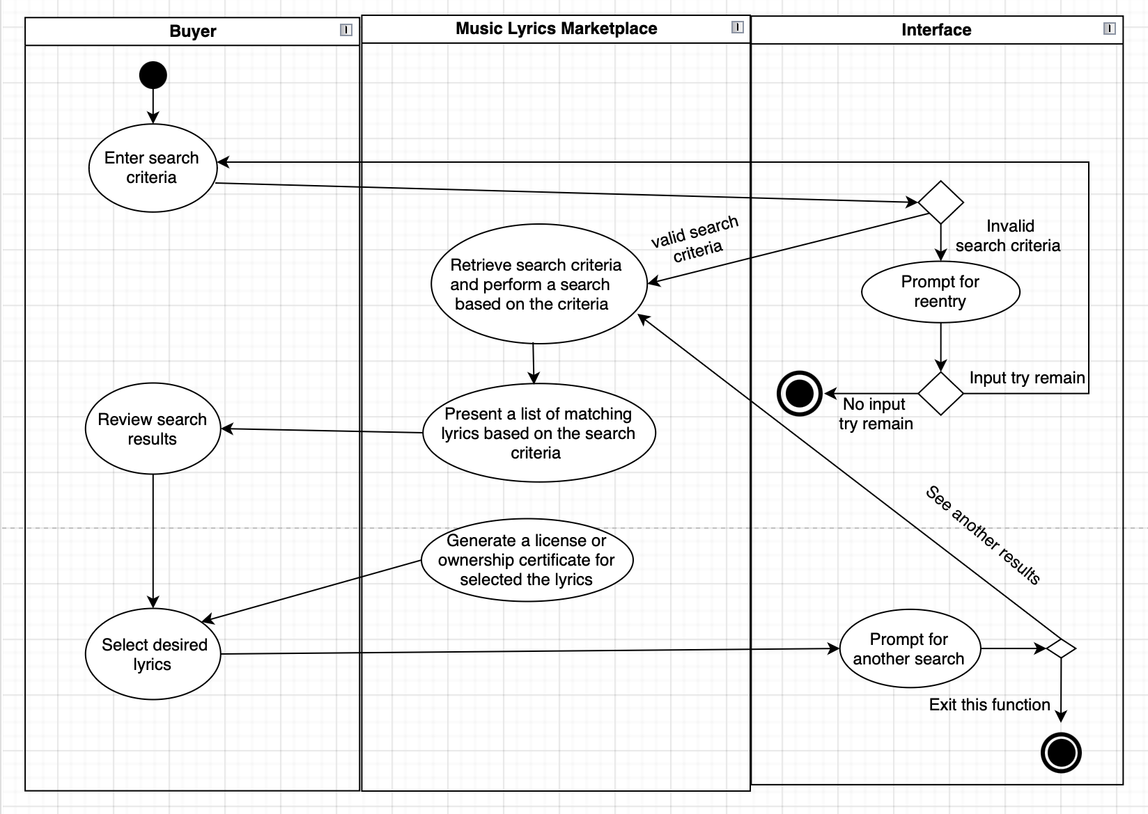

Flow of Activities:
1. User (Buyer) Lane:
- This lane represents the actions taken by the user, who is the buyer interested in searching for lyrics.
- Step 1: The user enters the search criteria, such as the song title, artist name, or keywords, into the interface provided by the Music Lyrics Marketplace.
- Step 2: After entering the criteria, the user reviews the search results presented by the Marketplace and selects the desired lyrics from the list.

2. Music Lyrics Marketplace Lane:
- This lane represents the actions taken by the Music Lyrics Marketplace system.
- Step 1: The Marketplace retrieves the search criteria entered by the user and performs a search based on these criteria.
- Step 2: Once the search is performed, the Marketplace presents a list of matching lyrics to the user based on the search criteria.
- Step 3: The Marketplace generates a license or ownership certificate for the selected lyrics chosen by the user.

3. Interface Lane:
- This lane represents the interface through which the user interacts with the Music Lyrics Marketplace system.
- Step 1: The interface displays the search interface where the user can input their search criteria. If the user inputs incorrect or excessive criteria, the interface notifies them accordingly.
- Step 2: The interface provides access and select options to the user after the Music Lyrics Marketplace enables them.

Deliverable #3 (1 mark) due week 6 for professor review and feedback – Joshua D.
Using “Microsoft Visio” draw a use case diagram illustrating all the use cases identified in deliverable 1 above grouped by sub-system. Add the output to section #4 of your SRS document.
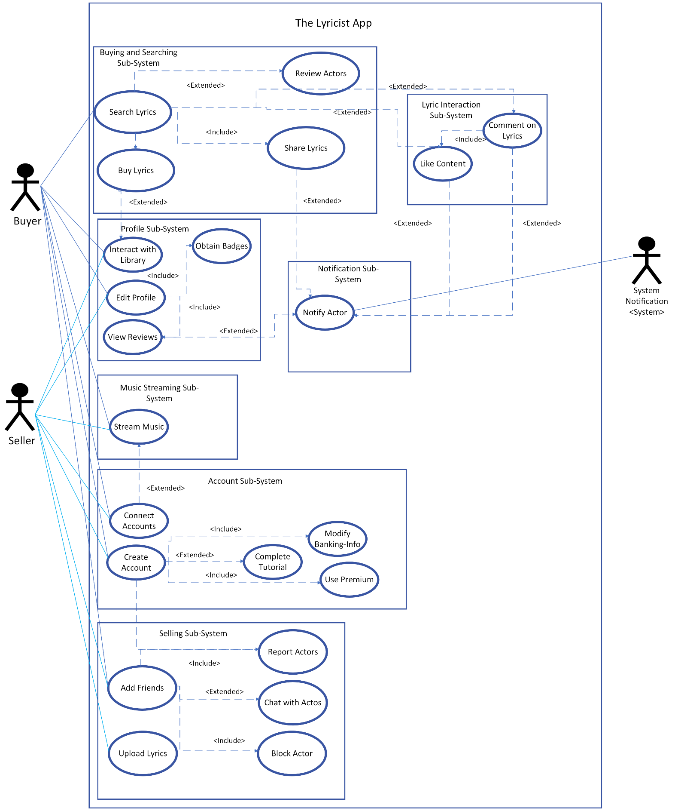
Deliverable #4 (2 mark) due week 8 for professor review and feedback-Julian
Based on the use case descriptions, use the “Noun” technique to identify a list of analysis classes related to the domain problem/opportunity of your project. Brainstorm with your team to identify the list of attributes related to each class and the class relationships, for example binary association, inheritance…etc. and describe these relationships, for example a customer places an order, an order belongs to one customer. Draw, using “Microsoft Visio” a first cut domain class diagram. Add the domain class diagram to Appendix E of your SRS document under class diagrams
Refer to Appendix 1 in your textbook for examples on Class diagrams, and the below links on how to Microsoft Visio
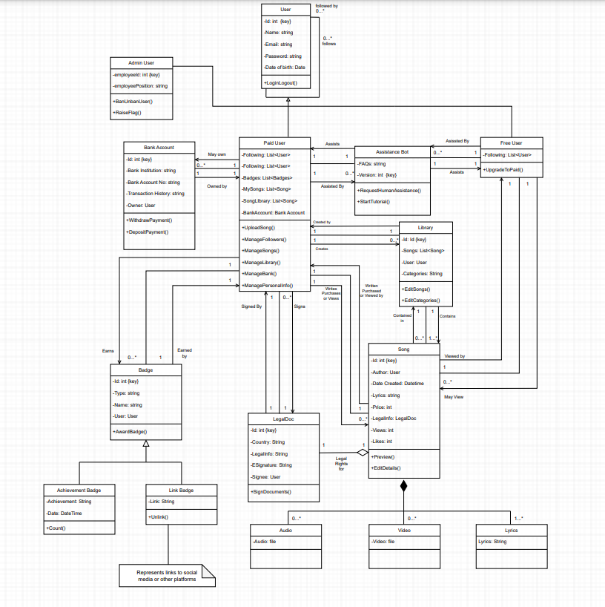

Deliverable #5 (2 mark) due week 8 for professor review and feedback-Rohaan
Brainstorm with your team to develop a set of Class responsibilities and collaboration “CRC cards” for all entity type classes. Add the CRC index cards to Appendix E of your SRS document under class diagrams.

 |  |  |  | Review Handler
 |  |  |  | The review handler will create, edit, delete, and get reviews regarding an account
 |  |  |  | Responsibility | Collaboration
 |  |  |  | Create Review | Review
 |  |  |  | Edit Review
 |  |  |  | Delete Review
 |  |  |  | Get Review
Profile Screen |  |  |  | Account Handler |  |  |  | Account |  |  |  | Review
This screen will display a selected user's profile information, if it is their own profile, they will be able to edit the displayed profile. |  |  |  | The account handler is used to create account's and get specific account information. |  |  |  | The account will store, and update account information. Each account will also store reviews towards the account. |  |  |  | Contains all the review details.
Responsibility | Collaboration |  |  | Responsibility | Collaboration |  |  | Responsibility | Collaboration |  |  | Responsibility | Collaboration
Get account information | Account Handler |  |  | Create Account | Account |  |  | Stores account information | Review |  |  | Get review rating | Profile Screen
Display specific account information | Review Handler |  |  | Get a specific account |  |  |  | Update account information | Account Handler |  |  | Get review text | Review Handler
Edit account information | Listing Handler |  |  |  |  |  |  | Stores Review |  |  |  | Be able to go to users’ profile who posted the review
Display account's Lyric Listings
Display Review(s)
Create a Review
Create Listing Screen |  |  |  | Listing Handler |  |  |  | Lyric Listing |  |  |  | Listing Information
This screen will accept user input to create a lyric listing. |  |  |  | The listing handler will create, delete, and collect lyric listings to be displayed in a specific screen. |  |  |  | The Lyric Listing will create, modify, and delete lyric information; as well as Getting lyric information. |  |  |  | Stores all the information for a lyric listing
Responsibility | Collaboration |  |  | Responsibility | Collaboration |  |  | Responsibility | Collaboration |  |  | Responsibility | Collaboration
Accept user input for listing details | Listing Handler |  |  | Create Lyric Listing | Lyric Listing |  |  | Get Listing information | Listing Information |  |  | Get Account username | Account
Accept an uploaded text file |  |  |  | Get Lyric Listing |  |  |  | Update Listing information |  |  |  | Get Account Banking Info
 |  |  |  | Delete Lyric Listing |  |  |  | Delete Listing Information |  |  |  | Get lyric text document
 |  |  |  |  |  |  |  | Create Listing Information |  |  |  | Get Account full name
 |  |  |  |  |  |  |  |  |  |  |  | Get Account phone number
 |  |  |  |  |  |  |  |  |  |  |  | Get Account email
 |  |  |  |  |  |  |  |  |  |  |  | Get listing cost
 |  |  |  |  |  |  |  |  |  |  |  | Get listing filters
Comment Screen |  |  |  | Comment Handler |  |  |  | Comment |  |  |  | Get Description
This screen will accept user input to create comments and display other users’ comments under a listing. |  |  |  | The comment handler will create comments under a listing, delete their own comments, and get other user's comments for a specific listing. |  |  |  | Stores all the information to a comment. |  |  |  | Get Additional Terms and Conditions
 |  |  |  |  |  |  |  |  |  |  |  | Get Legal Document to read
Responsibility | Collaboration |  |  | Responsibility | Collaboration |  |  | Responsibility | Collaboration
Accept user input in a text box | Comment Handler |  |  | Create Comment | Comment |  |  | Get comment text | Account
Display other account comments |  |  |  | Delete Comment |  |  |  | Get Account username
Remove comments |  |  |  | Get Comment
Home Screen |  |  |  | Feed Handler |  |  |  | Interest Prediction |  |  |  | Notification
Will recommend lyric listings on the main screen in the user's app. |  |  |  | Will generate recommendations for users using their collected user data. |  |  |  | Will contain specific data for a predicted interest of the user. |  |  |  | Will show notifications if the users are not on the app
Responsibility | Collaboration |  |  | Responsibility | Collaboration |  |  | Responsibility | Collaboration |  |  | Responsibility | Collaboration
Display other users' lyric listings | Feed Handler |  |  | Get all user data | Listing Handler |  |  | Get specific user data | Review |  |  | Notification regarding purchases | Purchase Handler
Display other popular sellers | Account Handler |  |  | Get lyric listings | Interest Prediction |  |  | Get specific keywords, and tags | Search Screen |  |  | User receives Notification about Chat system | Chat System
 |  |  |  | Create Interest Prediction |  |  |  | Get interest of a user |  |  |  | User receives Notification about Badges Obtained
 |  |  |  | Delete Interest Prediction
 |  |  |  | Update Interest Prediction
 |  |  |  | Match Interest Prediction to other lyrics
Search Screen |  |  |  | Purchase Handler |  |  |  | Lyric Library |  |  |  | Tutorial Bot
This screen will allow the user to search for a lyric or another user and display lyrics based on their search and app recommendations. |  |  |  | The purchase handler will process and complete the purchase transaction between the buyer and seller. |  |  |  | Will store and allow users to view uploaded and purchased lyrics. |  |  |  | Will introduce the users to the main functionalities that the app has to offer.
Responsibility | Collaboration |  |  | Responsibility: | Collaboration |  |  | Responsibility | Collaboration |  |  | Responsibility | Collaboration
Accept user input in search bar | Feed Handler |  |  | Transfer specified purchaser's funds to the company’s temporary bank account | Lyric Library |  |  | Store purchased and uploaded lyrics |  |  |  | Will introduce the user to Listing Handler | Listing Handler
Display other users’ lyric listings relevant to search and recommendations | Account Handler |  |  | Create content of email | Email Handler |  |  | View purchased and uploaded lyrics |  |  |  | Will introduce the user to Lyric Listing | Lyric Listing
Display users relevant to search | Listing Information |  |  | Send email content(s) to Email Handler |  |  |  | Delete purchased and uploaded lyrics |  |  |  | Will introduce the user to Profile Screen | Profile Screen
 |  |  |  | Add lyric to Lyric Library |  |  |  | Download purchased and uploaded lyrics
 |  |  |  | Sign the Legal Document before the transaction gets approved |  |  |  | Modify purchased and uploaded lyrics
Account Creation Screen |  |  |  | Email Handler |  |  |  | Email
This screen will only display on the app first being opened; the screen will accept user input to create a new account. |  |  |  | Will generate and send email notifications based on action performed within the app. |  |  |  | Will contain the specified information in the email for the user to view and keep for their records.
Responsibility | Collaboration |  |  | Responsibility | Collaboration |  |  | Responsibility | Collaboration
Accept input for account information | Account Handler |  |  | Get email content(s) | Email |  |  | Store email contents | Email Handler
Sends account information to Account Handler |  |  |  | Create email |  |  |  | Get email recipients
 |  |  |  | Send email
Listing Screen
This screen will display the details to a selected lyric listing and buy or delete the listing if conditions are met.
Responsibility | Collaboration
Display Listing information | Listing Handler
Delete listing | Purchase Handler
Purchase Lyric
Spotify Icon |  |  |  | Spotify Executor |  |  |  | Spotify Software
This icon will be permanently fixed to the top left corner of the screen and will allow users to open the Spotify app within the app. |  |  |  | The executor will execute the Spotify software within the Lyricist app. |  |  |  | The Spotify software will display the Spotify UI.
Responsibility | Collaboration |  |  | Responsibility | Collaboration |  |  | Responsibility: | Collaboration
Display Spotify icon | Spotify Executor |  |  | Run the Spotify Software | Spotify Software |  |  | Display Spotify UI | Spotify Executor
Allow user interaction with icon
Chat Handler
This Chat handler will allow users to communicate with other users through chat
Responsibility | Collaboration
Accept the user's message | Notification
Display the message to the person who was sent that message | Message Storage
Edit messages
Delete messages
Message Storage
This Message Storage will receive messages from Chat Handler and store those messages.
Responsibility | Collaboration
Store messages | Chat Handler

Deliverable #6 (2 mark) due week 9 for professor review and feedback-Kuan
Based on the responsibilities and collaborations identified in your CRC index cards update your first cut domain class diagram with the following:
a. Class attribute descriptions and visibilities
b. Signature methods with the respective parameters and visibilities
Add the class diagram to Appendix E of your SRS document under class diagrams.
